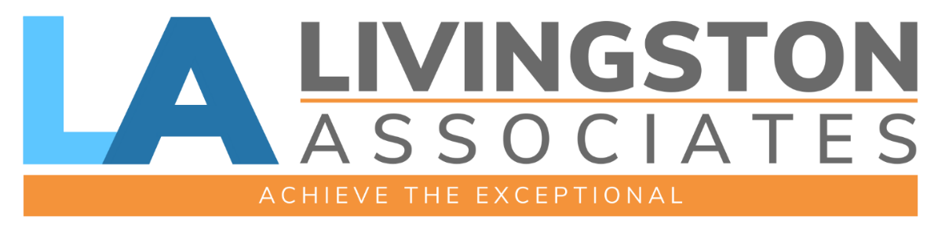

RECENT RECOGNITION:
- “Top Workplaces” for the past 4 years in a row (2022 – 2025)
- “Business of the Year” by Livingston County Chamber of Commerce (2023)
- Recipient of “Leaders in Construction” award from the Rochester Business Journal for Excellence in Construction & Real Estate (2023 – 2025)

Presented to:



161 East Avenue
Brockport, NY 14420

INTRODUCTION & OVERVIEW

Livingston Impact Advisors (LIA) offers a unique range of specialized solutions that support various key functions our clients may need as part of a vision for growth and organizational development. By providing high-value support services through a streamlined, single-source partnership, LIA empowers our clients to remain focused on accomplishing their core organizational goals and achieving exceptional results.

Essential Purpose
We believe that an organization's best form is only realized when its functional needs are met, and its goals can become its primary focus. LIA exists to make this possible. An intentional organization can transition from simply managing success, to growing success and achieving its full potential.

Vision
Thriving communities built by empowered organizations.

Mission
We are a dedicated team serving organizations with first-class excellence. We help our clients do what they need to do, so they can focus on what they want to do.

Organizational Values:

Service
Add value to all those you interact with.

Solutions-Focus
The "Can-do" approach to life.

Teamsmanship
Creating wins for others.

Humility
Think about yourself less.

Best-in-Class
Push the boundaries of what is best.

Experience
People will always remember how you made them feel.

PEOPLE + STRATEGY = EXECUTION.

PROPOSAL

Seymour Library – Facilitation and Campaign Strategy Development
- Facilitated Strategic Board Sessions (2)
- Preparation: Review of organizational documents and board meeting minutes (four hours)
- Format: two-hour guided discussions on vision and goals in order to achieve complete mission alignment (includes two hours of preparation and two hours of follow-up/creation of overview document)

- Fees: $1,200 per session ($2,400 total).

- Presentation of Outcomes From Board Sessions
- To occur at next scheduled board meeting
- Fee: $150

- Campaign Strategy Development
- Grant research (approximately 10 hours)
- Donor and financials review (approximately five hours)
- Development of two to three campaign options including capital campaign, community fundraising, and grant applications (approximately 10 hours)
- Presentation of options to board of directors (at Board meeting, approximately one to two hours)
- Fees: approximately $5,000

- Implementation of Campaign Strategy (*TBD based on strategy and proposed activity- and based on a one-year campaign)
Donor Outreach
- Feasibility study (approximately 15 hours: donor calls, interviews, and organization/presentation of feedback)
- New donor research and solicitation (approximately 20 hours)
- Direct Mail Campaign (10 hours plus cost of mail- TBD)
Capital Campaign
- Development of narrative (5 hours)
- Creation of promotional materials (10 hours plus cost of printing- TBD)
- Community outreach and other events and activities as developed from the campaign strategy (approximately 3-5 hours/week for one year)
Fees: billed at $150/hour (non-profit rate)

Involvement of Library Board: any involvement from the members of the board or volunteers will allow for a reduction in hours performed by LIA. This may be as much or as little as the board and volunteers are able to do.

